Creating Microservices for account and loan

**Loan - service:**

*LoanApplication.java:*

package com.cognizant.loan;

import org.springframework.boot.SpringApplication;

import org.springframework.boot.autoconfigure.SpringBootApplication;

import org.springframework.cloud.client.discovery.EnableDiscoveryClient;

*@SpringBootApplication*

*@EnableDiscoveryClient*

public class LoanApplication {

public static void main(String[] args) {

SpringApplication.*run*(LoanApplication.class, args);

}

}

*pom.xml:*

<?xml version="1.0" encoding="UTF-8"?>

<project xmlns="http://maven.apache.org/POM/4.0.0" xmlns:xsi="http://www.w3.org/2001/XMLSchema-instance"

xsi:schemaLocation="http://maven.apache.org/POM/4.0.0 https://maven.apache.org/xsd/maven-4.0.0.xsd">

<modelVersion>4.0.0</modelVersion>

<parent>

<groupId>org.springframework.boot</groupId>

<artifactId>spring-boot-starter-parent</artifactId>

<version>3.5.3</version>

<relativePath/> <!-- lookup parent from repository -->

</parent>

<groupId>com.cognizant</groupId>

<artifactId>loan</artifactId>

<version>0.0.1-SNAPSHOT</version>

<name>loan</name>

<description>Demo project for Spring Boot</description>

<url/>

<licenses>

<license/>

</licenses>

<developers>

<developer/>

</developers>

<scm>

<connection/>

<developerConnection/>

<tag/>

<url/>

</scm>

<properties>

<java.version>21</java.version>

</properties>

<dependencies>

<dependency>

<groupId>org.springframework.boot</groupId>

<artifactId>spring-boot-starter-web</artifactId>

</dependency>

<dependency>

<groupId>org.springframework.boot</groupId>

<artifactId>spring-boot-devtools</artifactId>

<scope>runtime</scope>

<optional>true</optional>

</dependency>

<dependency>

<groupId>org.springframework.boot</groupId>

<artifactId>spring-boot-starter-test</artifactId>

<scope>test</scope>

</dependency>

<dependency>

<groupId>org.springframework.cloud</groupId>

<artifactId>spring-cloud-starter-netflix-eureka-client</artifactId>

</dependency>

</dependencies>

<dependencyManagement>

<dependencies>

<dependency>

<groupId>org.springframework.cloud</groupId>

<artifactId>spring-cloud-dependencies</artifactId>

<version>2021.0.3</version>

<type>pom</type>

<scope>import</scope>

</dependency>

</dependencies>

</dependencyManagement>

<build>

<plugins>

<plugin>

<groupId>org.springframework.boot</groupId>

<artifactId>spring-boot-maven-plugin</artifactId>

</plugin>

</plugins>

</build>

</project>

*LoanController.java:*

package com.cognizant.loan.controller;

import org.springframework.web.bind.annotation.GetMapping;

import org.springframework.web.bind.annotation.PathVariable;

import org.springframework.web.bind.annotation.RestController;

*@RestController*

public class LoanController {

*@GetMapping*("/loans/{number}")

public String getLoanDetails(*@PathVariable* String number) {

return "{ number: \"H00987987972342\", type: \"car\", loan: 400000, emi: 3258, tenure: 18 }";

}

}

*Application.properties:*

eureka.client.service-url.defaultZone=http://localhost:8761/eureka/

spring.application.name=loan-service

server.port=8081

**Output:**

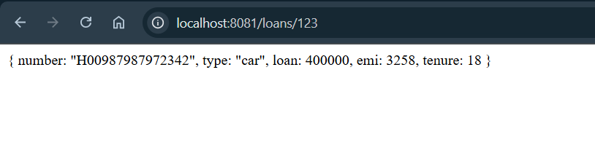

**Account-service:**

*AccountApplication.java:*

package com.cognizant.account;

import org.springframework.boot.SpringApplication;

import org.springframework.boot.autoconfigure.SpringBootApplication;

import org.springframework.cloud.client.discovery.EnableDiscoveryClient;

*@SpringBootApplication*

*@EnableDiscoveryClient*

public class AccountApplication {

public static void main(String[] args) {

SpringApplication.*run*(AccountApplication.class, args);

}

}

*AccountController.java:*

package com.cognizant.account.controller;

import org.springframework.web.bind.annotation.GetMapping;

import org.springframework.web.bind.annotation.PathVariable;

import org.springframework.web.bind.annotation.RestController;

*@RestController*

public class AccountController {

*@GetMapping*("/accounts/{number}")

public String getAccountDetails(*@PathVariable* String number) {

return "{ number: \"00987987973432\", type: \"savings\", balance: 234343 }";

}

}

*pom.xml:*

<?xml version="1.0" encoding="UTF-8"?>

<project xmlns="http://maven.apache.org/POM/4.0.0" xmlns:xsi="http://www.w3.org/2001/XMLSchema-instance"

xsi:schemaLocation="http://maven.apache.org/POM/4.0.0 https://maven.apache.org/xsd/maven-4.0.0.xsd">

<modelVersion>4.0.0</modelVersion>

<parent>

<groupId>org.springframework.boot</groupId>

<artifactId>spring-boot-starter-parent</artifactId>

<version>3.5.3</version>

<relativePath/> <!-- lookup parent from repository -->

</parent>

<groupId>com.cognizant</groupId>

<artifactId>account</artifactId>

<version>0.0.1-SNAPSHOT</version>

<name>account</name>

<description>Demo project for Spring Boot</description>

<url/>

<licenses>

<license/>

</licenses>

<developers>

<developer/>

</developers>

<scm>

<connection/>

<developerConnection/>

<tag/>

<url/>

</scm>

<properties>

<java.version>21</java.version>

</properties>

<dependencies>

<dependency>

<groupId>org.springframework.boot</groupId>

<artifactId>spring-boot-starter-web</artifactId>

</dependency>

<dependency>

<groupId>org.springframework.boot</groupId>

<artifactId>spring-boot-devtools</artifactId>

<scope>runtime</scope>

<optional>true</optional>

</dependency>

<dependency>

<groupId>org.springframework.boot</groupId>

<artifactId>spring-boot-starter-test</artifactId>

<scope>test</scope>

</dependency>

<dependency>

<groupId>org.springframework.cloud</groupId>

<artifactId>spring-cloud-starter-netflix-eureka-client</artifactId>

</dependency>

</dependencies>

<dependencyManagement>

<dependencies>

<dependency>

<groupId>org.springframework.cloud</groupId>

<artifactId>spring-cloud-dependencies</artifactId>

<version>2021.0.3</version>

<type>pom</type>

<scope>import</scope>

</dependency>

</dependencies>

</dependencyManagement>

<build>

<plugins>

<plugin>

<groupId>org.springframework.boot</groupId>

<artifactId>spring-boot-maven-plugin</artifactId>

</plugin>

</plugins>

</build>

</project>

*Application.properties:*

eureka.client.service-url.defaultZone=http://localhost:8761/eureka/

spring.application.name=account-service

**Output:**

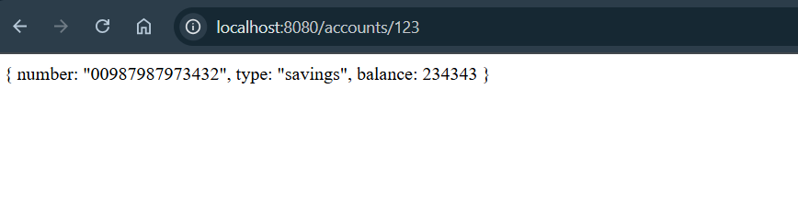

**Eureka-discovery-server:**

*EurekaDiscoveryServerApplication.java:*

package com.cognizant.eureka_discovery_server;

import org.springframework.boot.SpringApplication;

import org.springframework.boot.autoconfigure.SpringBootApplication;

import org.springframework.cloud.netflix.eureka.server.EnableEurekaServer;

*@SpringBootApplication*

*@EnableEurekaServer*

public class EurekaDiscoveryServerApplication {

public static void main(String[] args) {

SpringApplication.*run*(EurekaDiscoveryServerApplication.class, args);

}

}

*Application.properties:*

spring.application.name=eureka-discovery-server

server.port=8761

eureka.client.register-with-eureka=false

eureka.client.fetch-registry=false

logging.level.com.netflix.eureka=OFF

logging.level.com.netflix.discovery=OFF

*pom.xml:*

<?xml version="1.0" encoding="UTF-8"?>

<project xmlns="http://maven.apache.org/POM/4.0.0" xmlns:xsi="http://www.w3.org/2001/XMLSchema-instance"

xsi:schemaLocation="http://maven.apache.org/POM/4.0.0 https://maven.apache.org/xsd/maven-4.0.0.xsd">

<modelVersion>4.0.0</modelVersion>

<parent>

<groupId>org.springframework.boot</groupId>

<artifactId>spring-boot-starter-parent</artifactId>

<version>3.5.3</version>

<relativePath/> <!-- lookup parent from repository -->

</parent>

<groupId>com.cognizant</groupId>

<artifactId>eureka-discovery-server</artifactId>

<version>0.0.1-SNAPSHOT</version>

<name>eureka-discovery-server</name>

<description>Demo project for Spring Boot</description>

<url/>

<licenses>

<license/>

</licenses>

<developers>

<developer/>

</developers>

<scm>

<connection/>

<developerConnection/>

<tag/>

<url/>

</scm>

<properties>

<java.version>21</java.version>

<spring-cloud.version>2025.0.0</spring-cloud.version>

</properties>

<dependencies>

<dependency>

<groupId>org.springframework.cloud</groupId>

<artifactId>spring-cloud-starter-netflix-eureka-server</artifactId>

</dependency>

<dependency>

<groupId>org.springframework.boot</groupId>

<artifactId>spring-boot-starter-test</artifactId>

<scope>test</scope>

</dependency>

</dependencies>

<dependencyManagement>

<dependencies>

<dependency>

<groupId>org.springframework.cloud</groupId>

<artifactId>spring-cloud-dependencies</artifactId>

<version>${spring-cloud.version}</version>

<type>pom</type>

<scope>import</scope>

</dependency>

</dependencies>

</dependencyManagement>

<build>

<plugins>

<plugin>

<groupId>org.springframework.boot</groupId>

<artifactId>spring-boot-maven-plugin</artifactId>

</plugin>

</plugins>

</build>

</project>

**Output:**

